Project Development - Database design

Reading Data from Tables:

## Filter Data :

1. Where Clause : where clause will provide the condition for the select statement

Syntax: select Selmect_list from Table_Name where Condition;

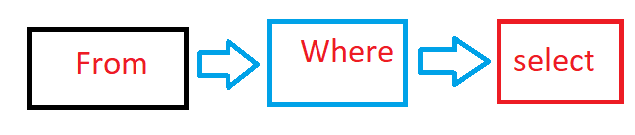

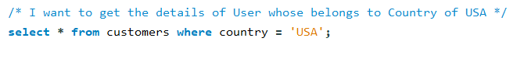

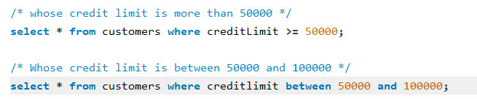

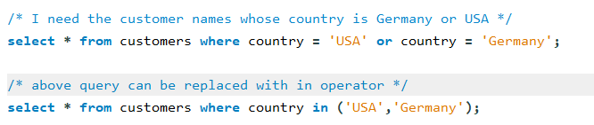

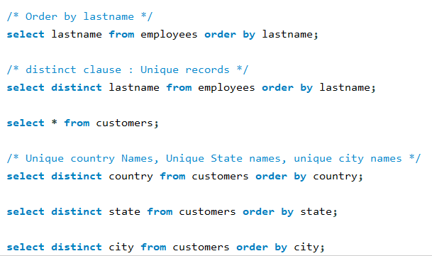

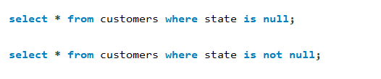

Difference between Group by and distinct :

Generally distinct is a special kind of group by clause and the difference is group by sorts the result set and distinct does not sort the result set.

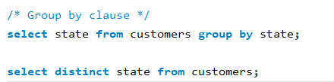

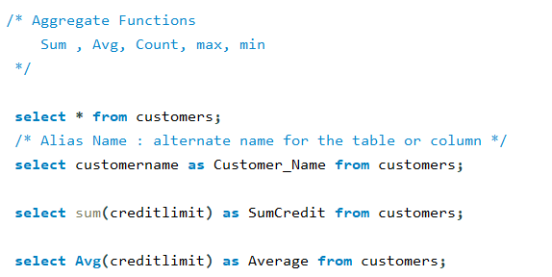

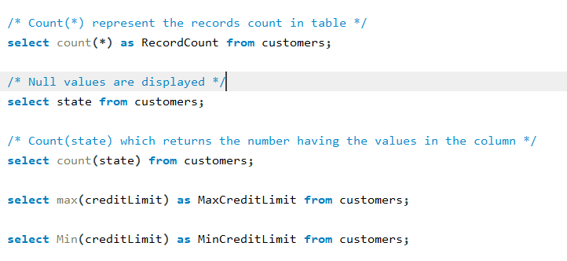

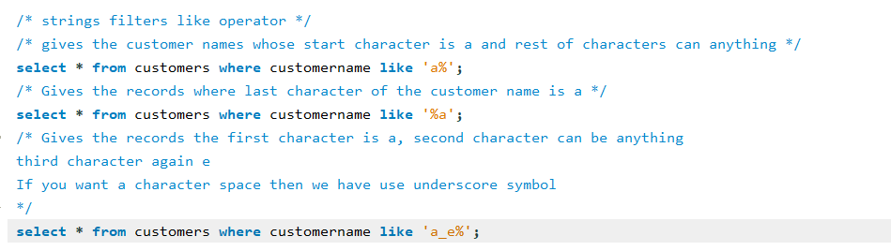

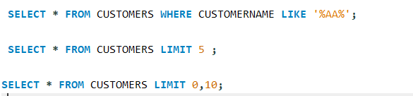

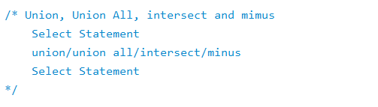\

Union: Allows to combine the two or more results sets of queries into a single result set. Both select statements should have the same type data columns. Union operator will removes the duplicates.

